KERATAN AKHBAR
23 Jun2021 (Wednesday)

Harian Metro
Lokasi sebenar Sajat belum diketahui | 1
Sinar Harian
MAIS belum tahu lokasi sebenar Nur Sajat bersembunyi | 2
MAIS, JAIS bincang SOP ibadah korban | 3
PAID Kuala Selangor akan beri nasihat isu laungan azan | 4
Selangor TV
MB Pelawa Sertai Saringan Percuma DUN Kajang, 26 Jun | 5
The Star
Authorities issue fines for failure to wear face masks, trading without licences | 6
Anger over road project delays | 7
China Press
Selangor offers discounts for people over 50 years old who take Grab to the vaccination center | 8
Sin Chew Daily
Chaotic vaccination in Klang; Suddenl rescheduling of appointments to distant locations | 9
Nanyang Siang Pau
Li Fuhao: Three to four hundred people a day miss out as vaccination dates suddenly change | 10
Guang Ming Daily
WOH spends RM300 million on negative pressure ambulances; Pakatan Harapan refute waste of public funds as unhelpful to fight pandemic. | 11

KERATAN AKHBAR
23 June 2021
Akhbar | : | Harian Metro
Tajuk Berita | : | Lokasi sebenar Sajat belum diketahui
Muka Surat | : | 20

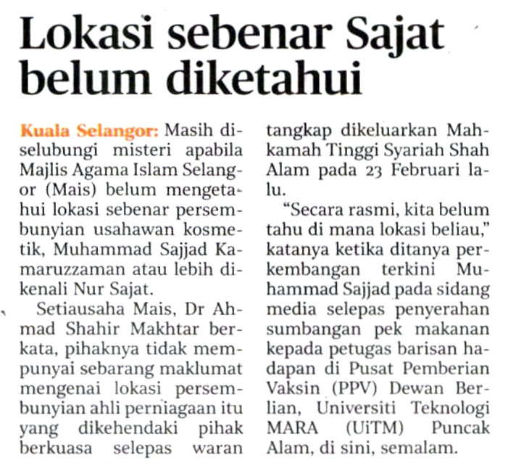
KERATAN AKHBAR
23 June 2021
Akhbar | : | Sinar Harian
Tajuk Berita | : | MAIS belum tahu lokasi sebenar Nur Sajat bersembunyi
Muka Surat | : | 24

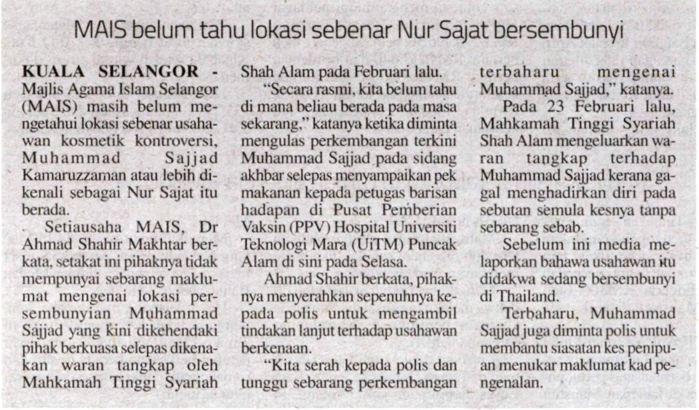
KERATAN AKHBAR
23 June 2021
Akhbar | : | Sinar Harian
Tajuk Berita | : | MAIS, JAIS bincang SOP ibadah korban
Muka Surat | : | 24

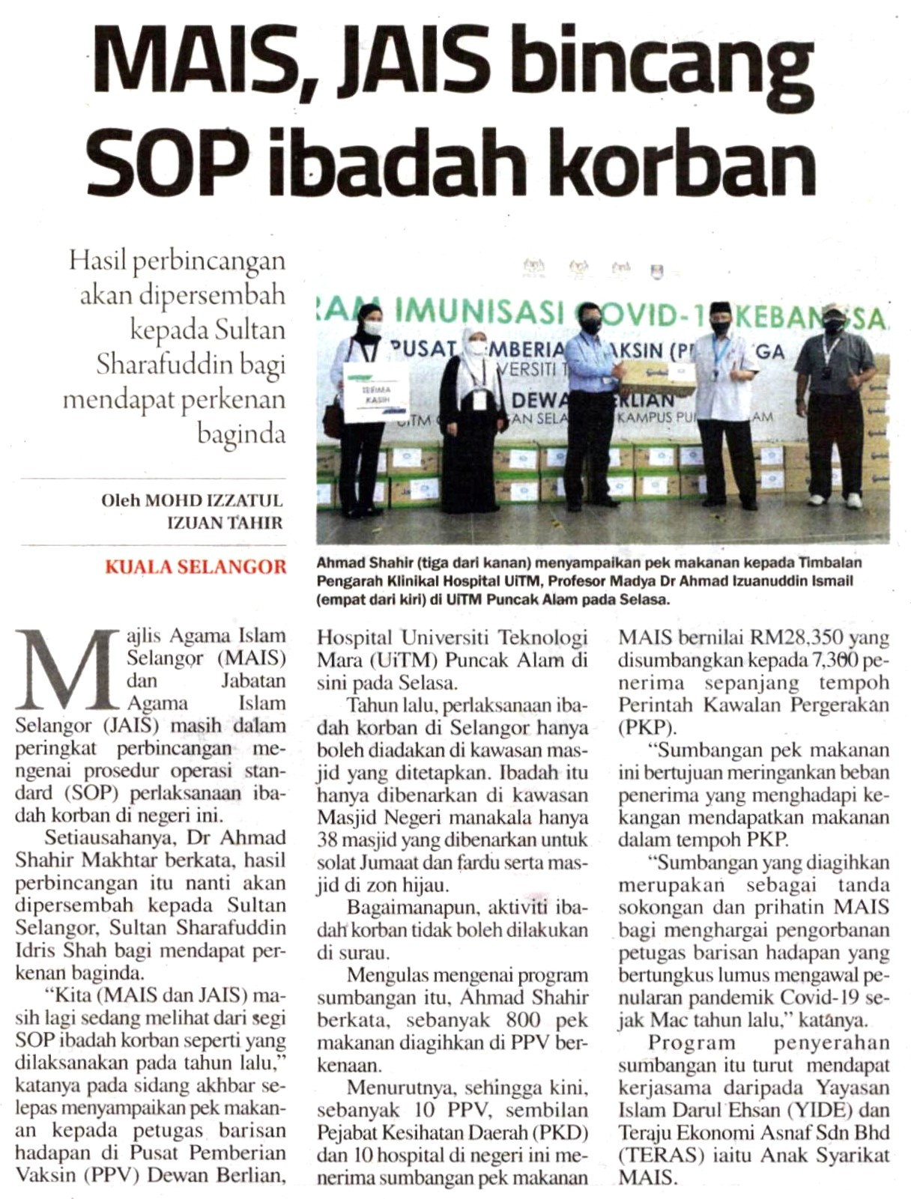
KERATAN AKHBAR
23 June 2021
Akhbar | : | Sinar Harian
Tajuk Berita | : | PAID Kuala Selangor akan beri nasihat isu laungan azan
Muka Surat | : | 24

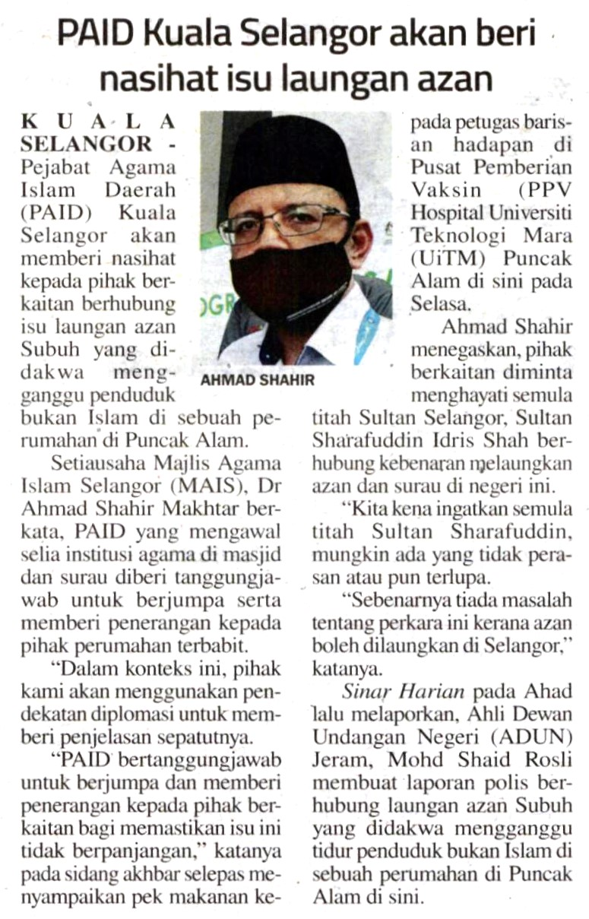
KERATAN AKHBAR
22 June 2021
Akhbar | : | Selangor TV
Tajuk Berita | : | MB Pelawa Sertai Saringan Percuma DUN Kajang, 26 Jun
Muka Surat | : | -

KERATAN AKHBAR
23 June 2021
Akhbar | : | The Star
Tajuk Berita | : | Authorities issue fines for failure to wear face masks, trading without licences
Muka Surat | : | 2

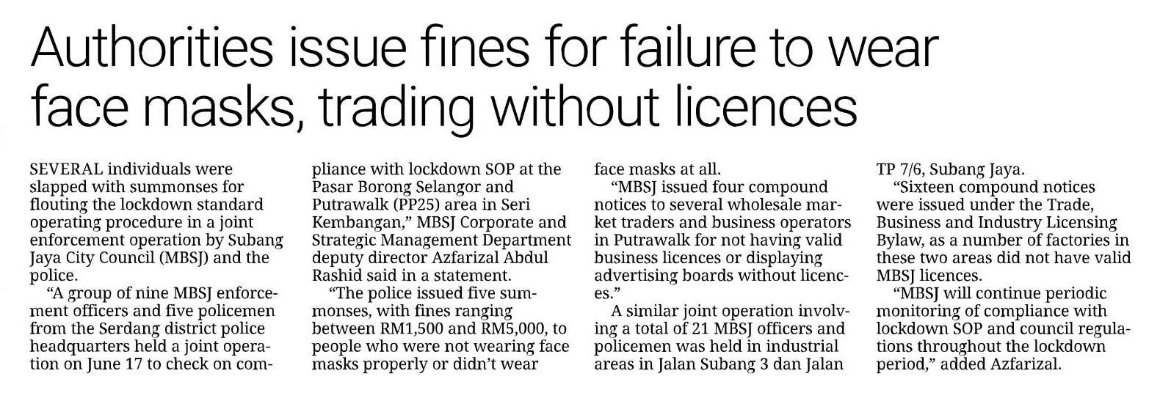
KERATAN AKHBAR
23 June 2021
Akhbar | : | The Star
Tajuk Berita | : | Anger over road project delays
Muka Surat | : | 4

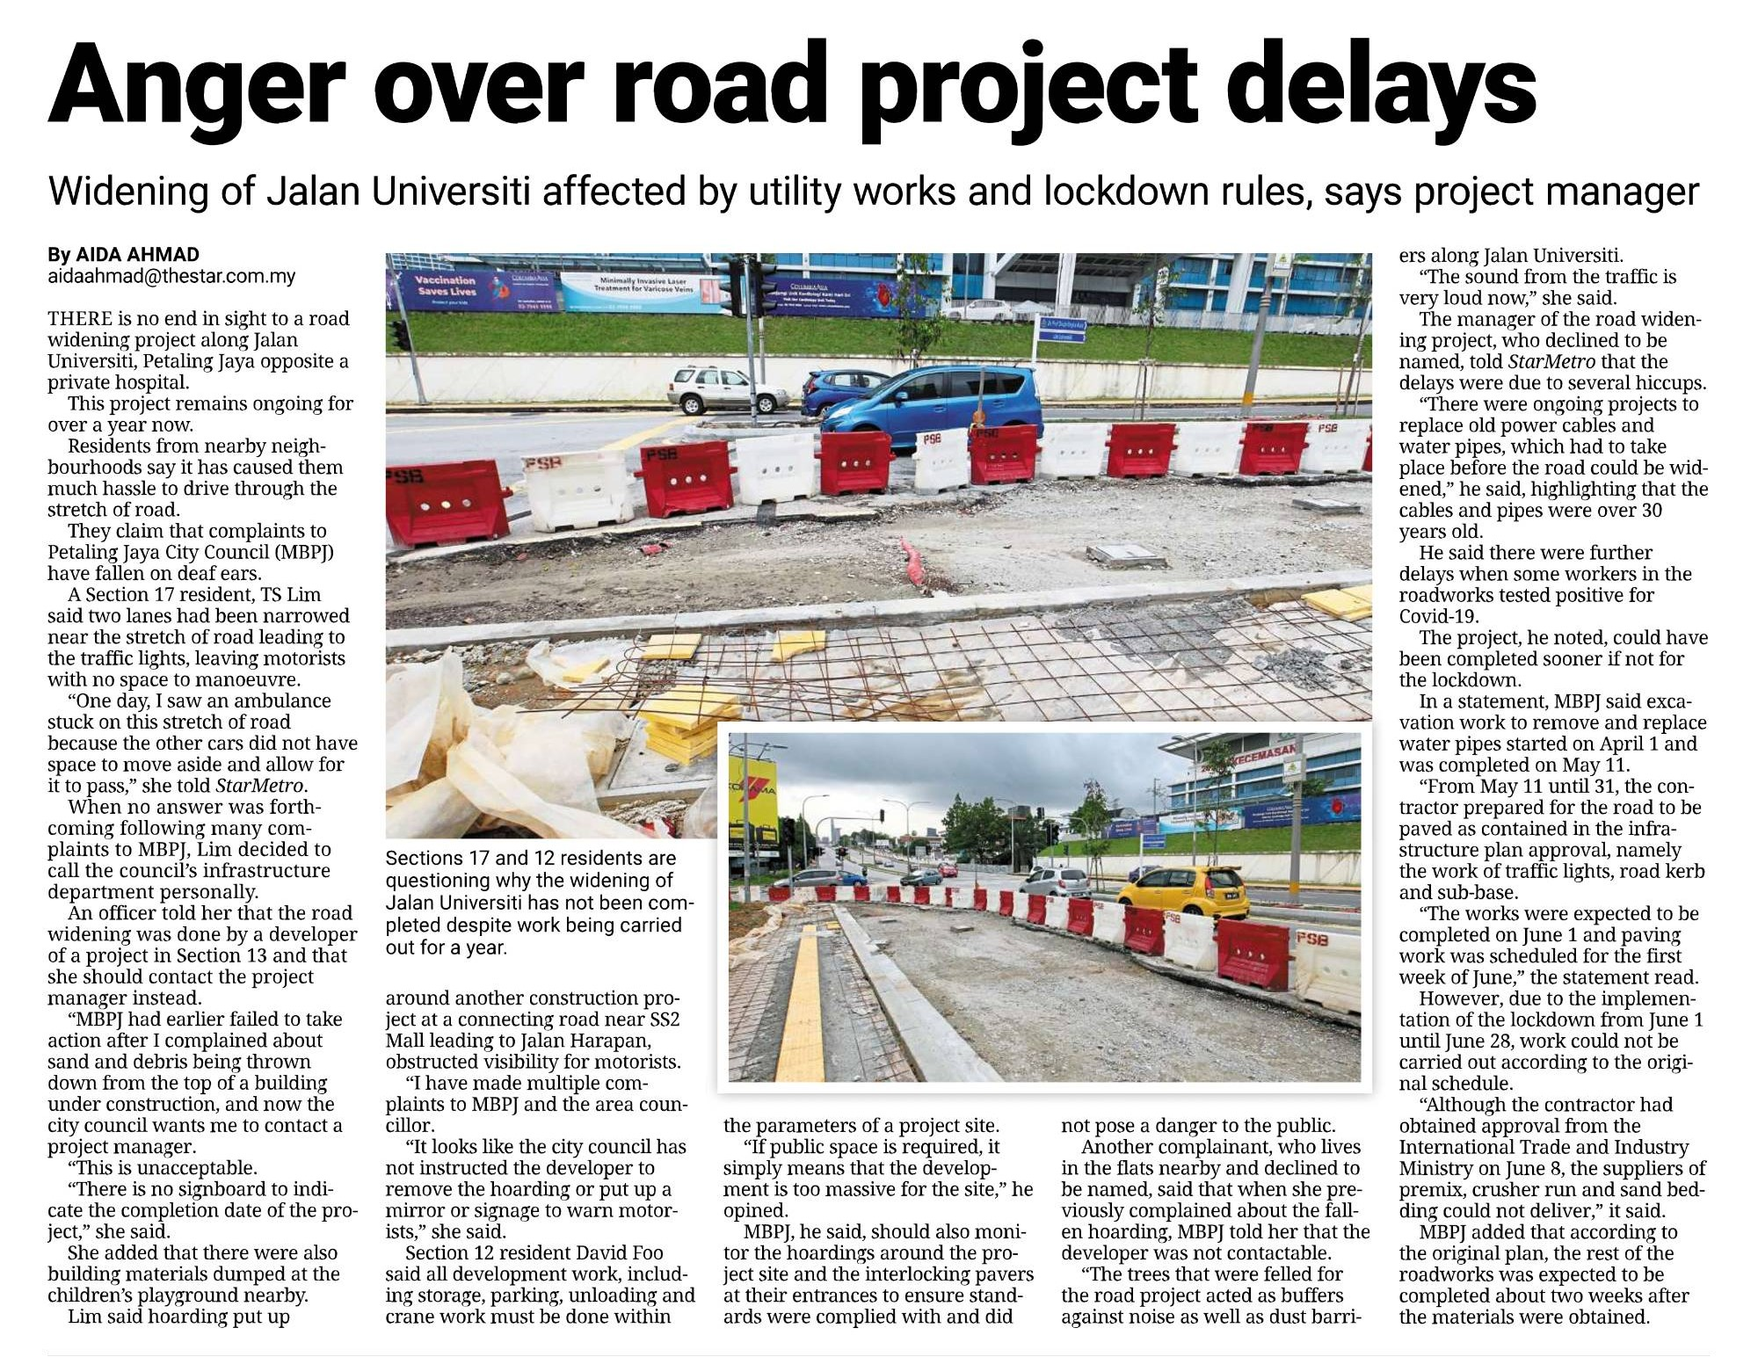
KERATAN AKHBAR
22 June 2021
Akhbar | : | China Press
Tajuk Berita | : | Selangor offers discounts for people over 50 years old who take Grab to the vaccination center
Muka Surat | : | 3

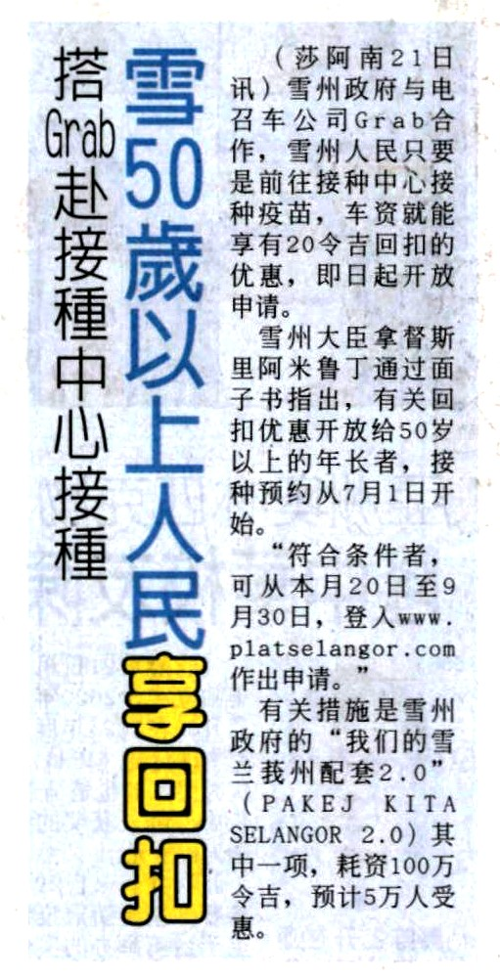
KERATAN AKHBAR
23 June 2021
Akhbar | : | Sin Chew Daily
Tajuk Berita | : | Chaotic vaccination in Klang; Suddenl rescheduling of appointments to distant locations
Muka Surat | : | 3

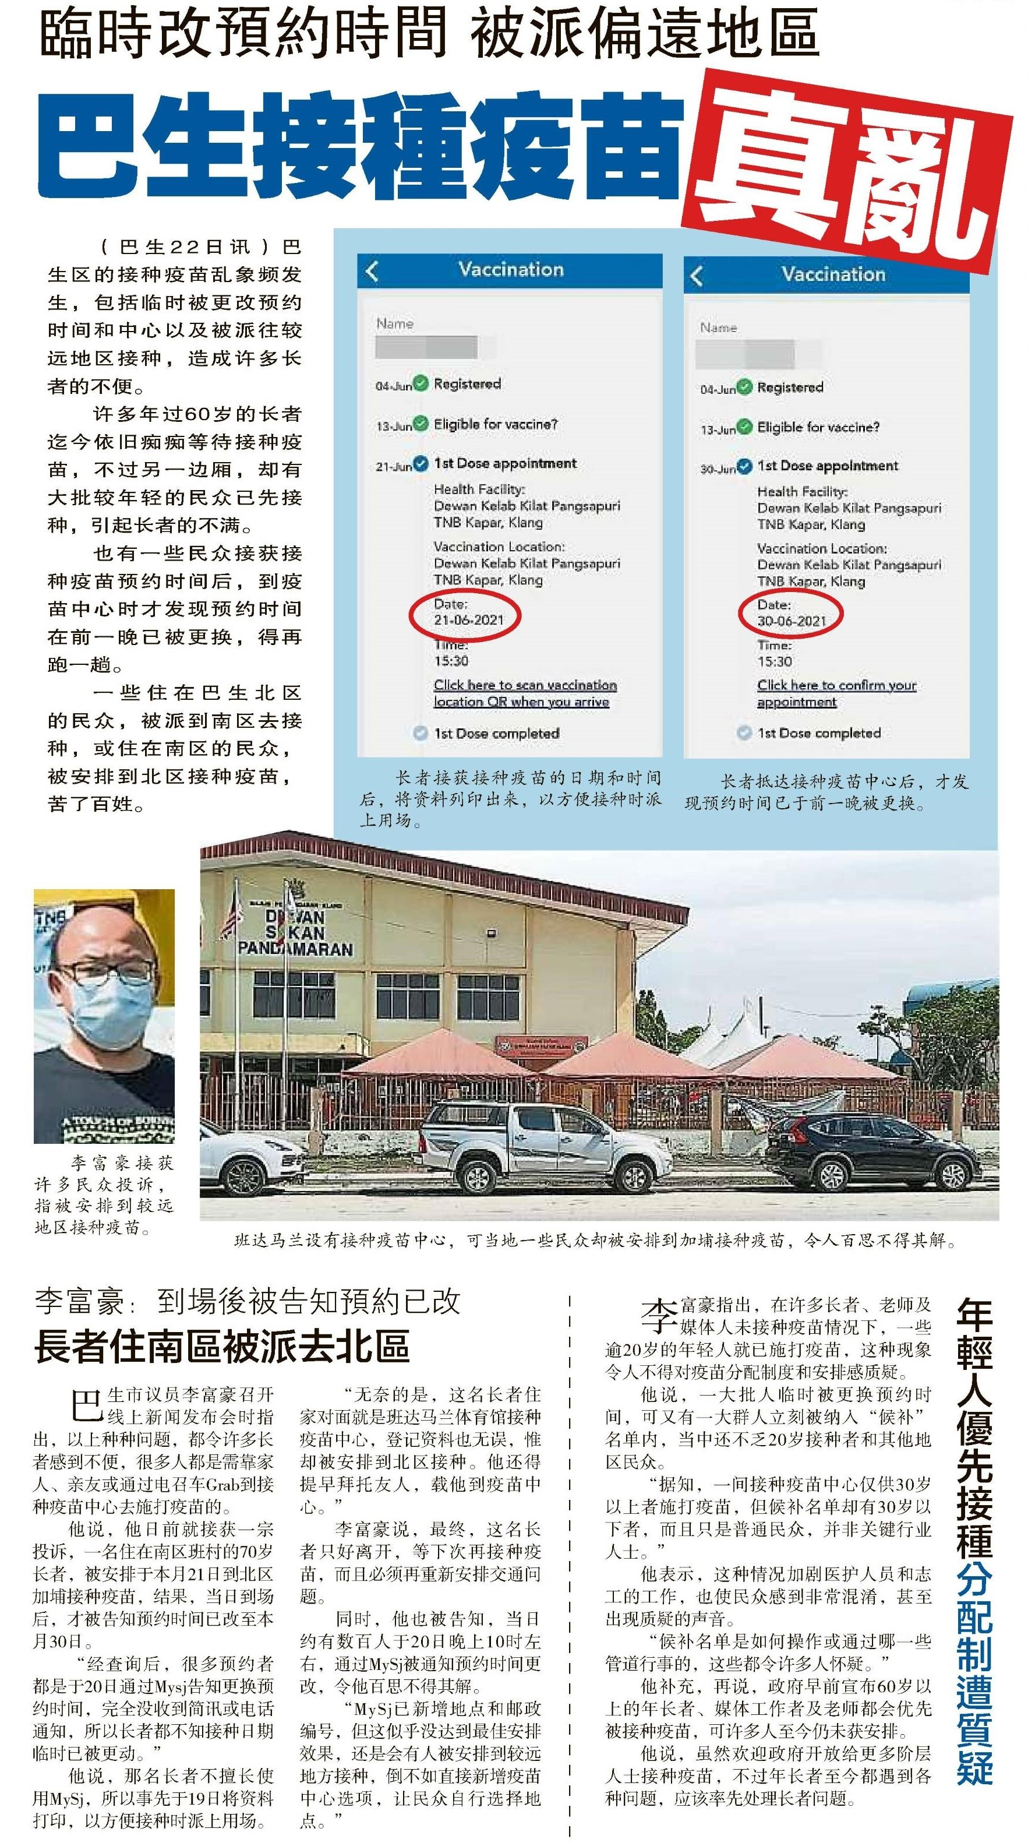
KERATAN AKHBAR
23 June 2021
Akhbar | : | Nanyang Siang Pau
Tajuk Berita | : | Li Fuhao: Three to four hundred people a day miss out as vaccination dates suddenly change
Muka Surat | : | 17

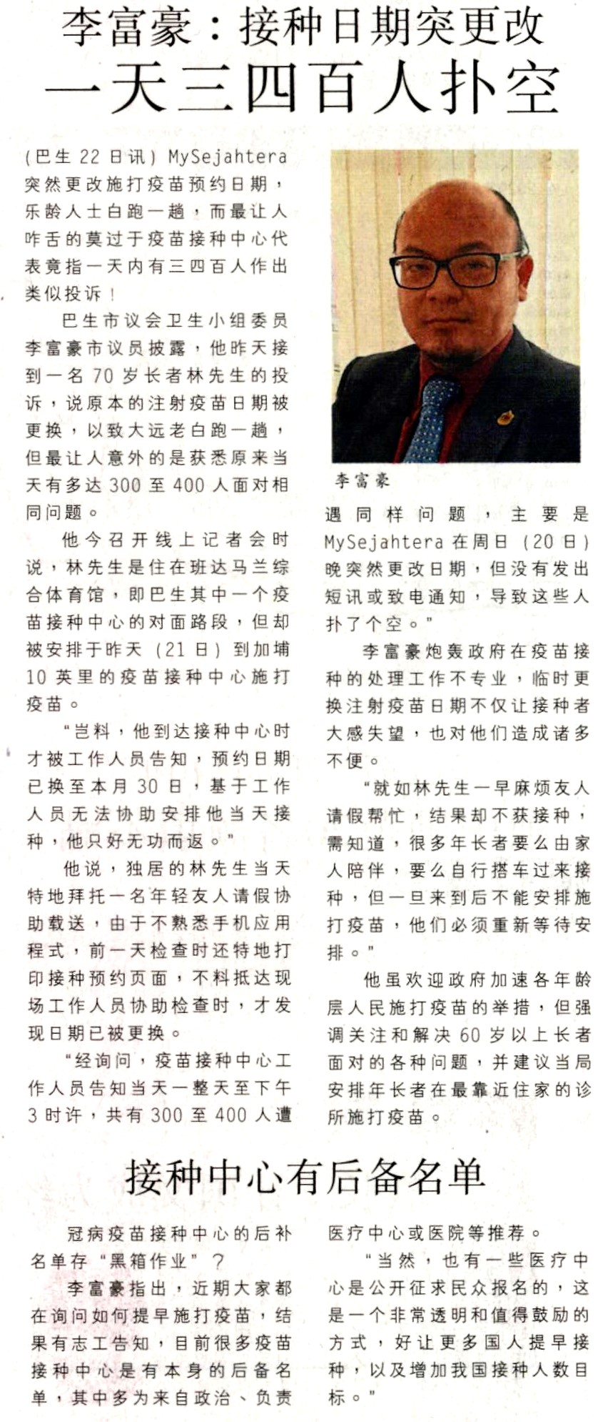
KERATAN AKHBAR
23 June 2021
Akhbar | : | Guang Ming Daily
Tajuk Berita | : | WOH spends RM300 million on negative pressure ambulances; Pakatan Harapan refute waste of public funds as unhelpful to fight pandemic.
Muka Surat | : | 7

